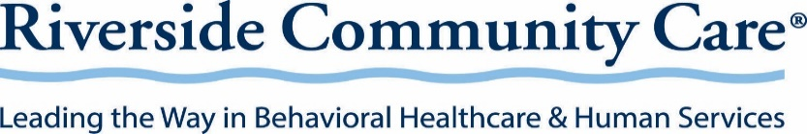

Connect2Recovery (C2R) NC-8 Recovery Coach Referral Form
Email: NC-8@riversidecc.org
To evaluate your referral for C2R services, please complete this form in full and email to NC-8@riversidecc.org. Please include a signed release if available. Once the information is received, program management will review within 48 business hours.

Referral Date:

Referral Source Name, Agency, Ph#:

Personal Information:
Full Name: |  | SSN: | DOB: | Gender:
Mailing Address: ☐ Check if homeless |  | Town/City: | State: | Zip:
Phone Number: ☐ Home ☐ Cell | Emergency Contact Name & Relation: |  | Emergency Contact Phone:
Race: | Ethnicity: |  | Marital Status:
Insurance Plan Name and ID#

What Substance(s) are you seeking Recovery Coach support for?

Providers: Please include Medical, Psychiatric, Legal, Natural Supports, Other
Agency | Role | Contact Name | Contact Telephone # (s)

Referral Information:
Why does the person want Recovery Coach services, and what are they hoping to gain?

Does the person have any current or past recovery time? Please describe.

Please describe any current or past legal concerns. (Has there been any criminal justice involvement within the past year)

GOALS
Please check all that apply. Include additional goals if needed.

☐ Substance Use ☐ Mental Health ☐ Medical
☐Recovery supports or 12-step ☐Therapy/counseling ☐Primary Care
☐Therapy/counseling ☐Psychiatrist/medication ☐Specialists
☐IOP/SOAP/day structure ☐DMH referral ☐Dental
☐MAT (e.g., methadone, suboxone) ☐Partial/day treatment: ☐Other:
☐Other: ☐Other:

☐ Housing ☐ Financial ☐ Legal issues
☐Public housing applications ☐SNAP/EAEDC/TAFDC ☐ Needs day structure
☐Sober/recovery housing ☐SSI/SSDI ☐ Lacks social/sober supports
☐Shelter/safe housing ☐Employment/Career Center ☐ Lacks transportation to essential medical
☐Other: ☐Mass Rehab and behavioral health appointments
☐Other:_________ ☐ Temporary assistance with transportation

Is there a history of violence or safety concerns? ☐Yes ☐No If yes,
Violent to: | Most recent date: | Information:
☐ Self
☐ Others

Questions may be directed to Dan Foley via email, NC-8@riversidecc.org

